## Student: Huynh Vo

## Homework 2

**Answer 1. First, I went to Notepad++, then Cygwin, then Ne4j**

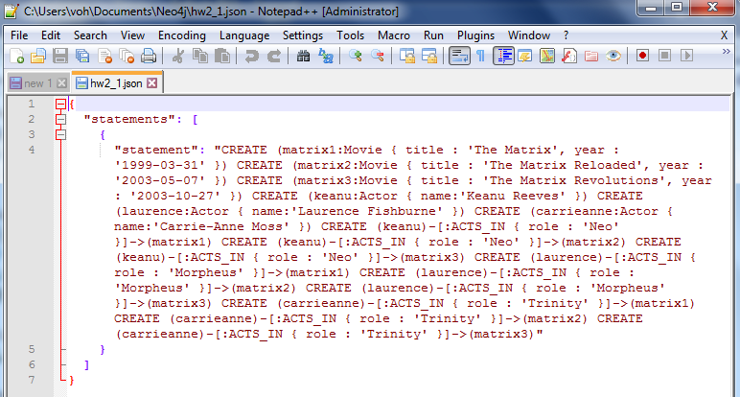



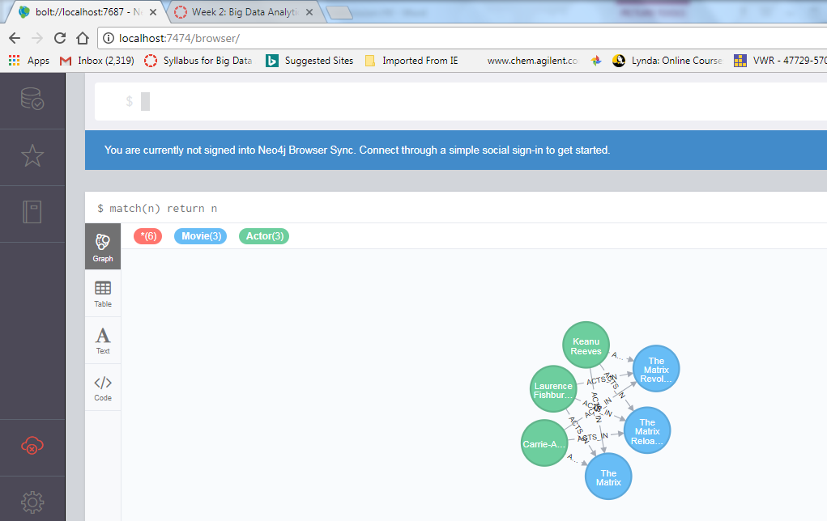

**Problem 2**. Keanu Reeves acted in the movie “John Wick” which is not in the database. That movie was directed by Chad Stahelski and David Leitch. Cast of the movie included William Dafoe and Michael Nyquist. Demonstrate that you have successfully brought data about John Wick movie into the database. You can use Cypher Browser or any other means. Delete above movie and all the cast except Keanu Reeves.

(15%)

**Answer:**

**In Cypher:**

**CREATE(JohnWick:Movie {title:'John Wick'}) CREATE(William:Actor**

**{name:'William Dafoe'})**

**CREATE(Michael:Actor {name:'Michael Nyquist'})**

**CREATE(Chad:Director{name:'Chad Stahelski'})**

**CREATE(David:Director{name:'David Leitch'}) CREATE(William)-[:ACTS_IN {role:'Marcus'}]->(JohnWick) CREATE(Michael)-[:ACTS_IN {role:'Viggo Tarasov'}]->(JohnWick) CREATE(Chad)-[:Directed {number:'one'}]-**

**>(JohnWick) CREATE(David)-[:Directed {number:'two'}]->(JohnWick)**

**Match(n) return n**

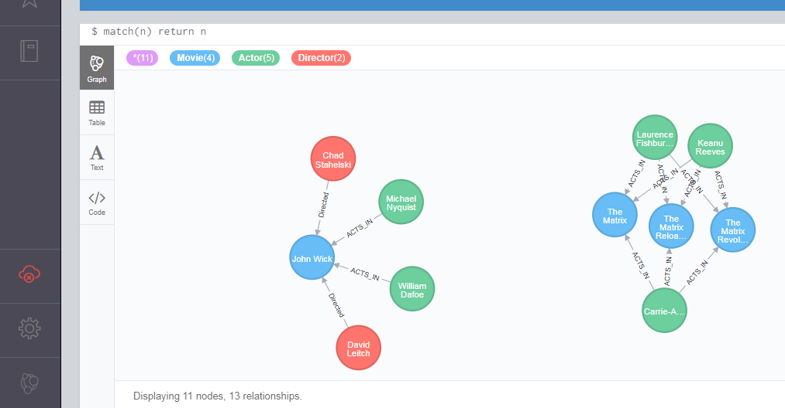

**Then, in Cypher**

**MATCH (k:Actor{name : 'Keanu Reeves'}), (m:Movie{title:'John Wick'}) CREATE (k)-[:ACTS_IN]->(m)**

**Match(n) return n**

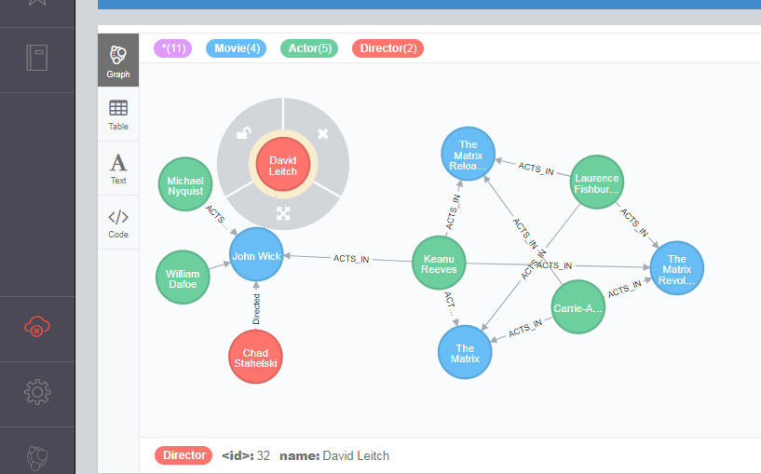

**Now delete part, in Cypher:**

**MATCH (d2:Actor{}) ,(m1:Movie{title:"John Wick"}),(d3:Director{}) where NOT(d2.name="Keanu Reeves") and m1.title ="John Wick" and (d2)-->(m1) detach delete d2,d3,m1**

**Match(n) return n**

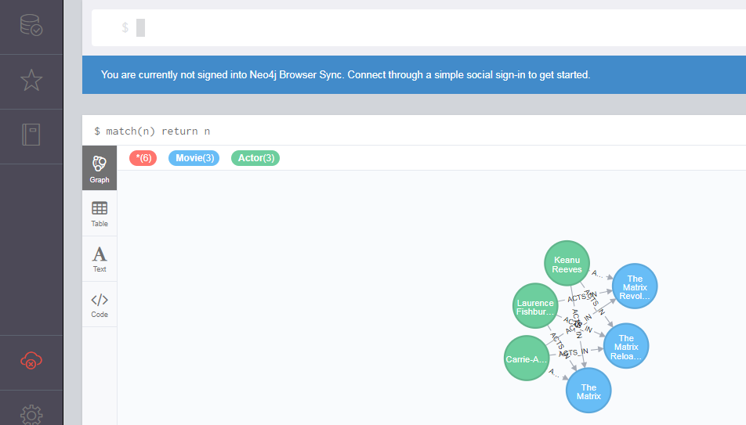

**Problem 3.** Addall the actors and the roles they played in this movie “John Wick” to the database using JAVA REST API or some other APIs for Neo4J in a language of your choice (not Curl). Demonstrate that you have successfully brought data about John Wick movie into the database. You can use Cypher Browser or any other means.

(15%)

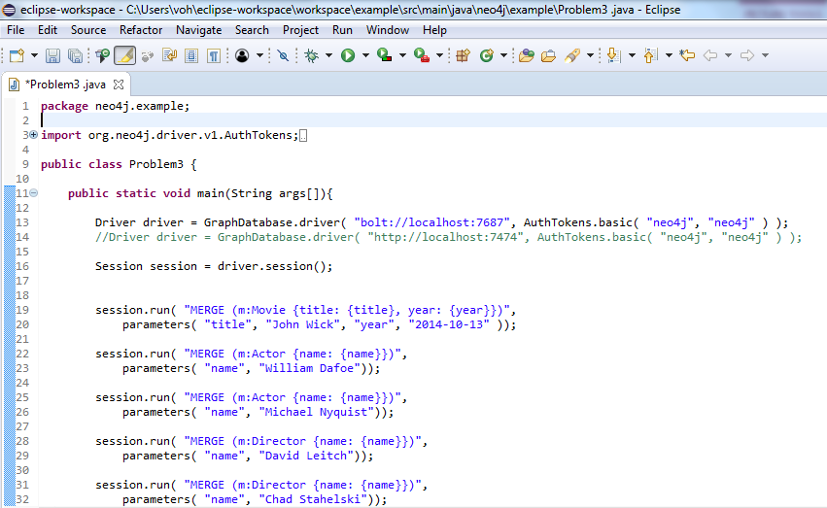

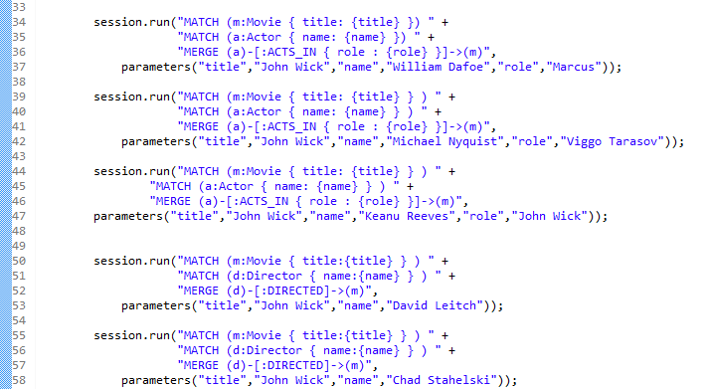

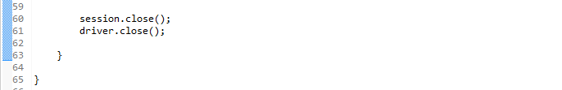

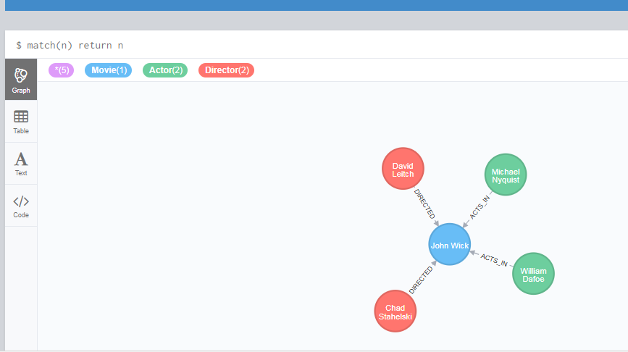

**Problem 4**. Find a list of actors playing in movies in which Keanu Reeves played. Find directors of movies in which K. Reeves played. Please use any language of your convenience (Java, Python, C#, R, curl). Verify your results using Cypher queries in Cypher Browser

(15%)

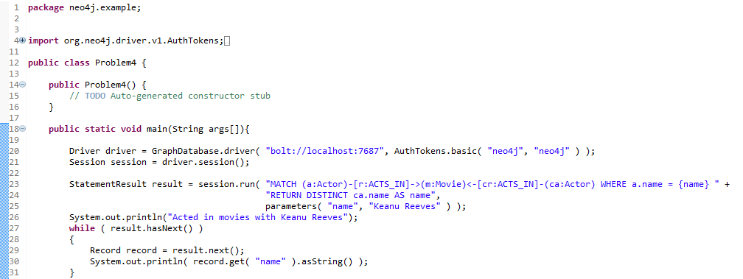

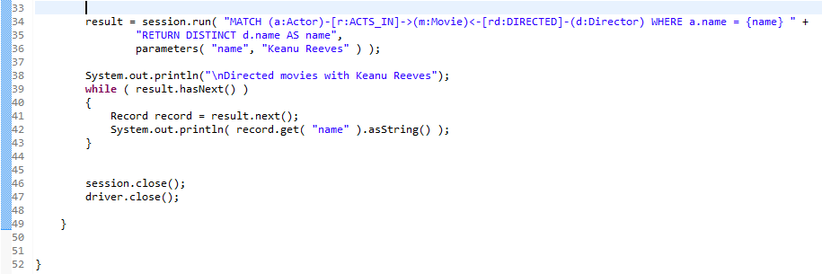



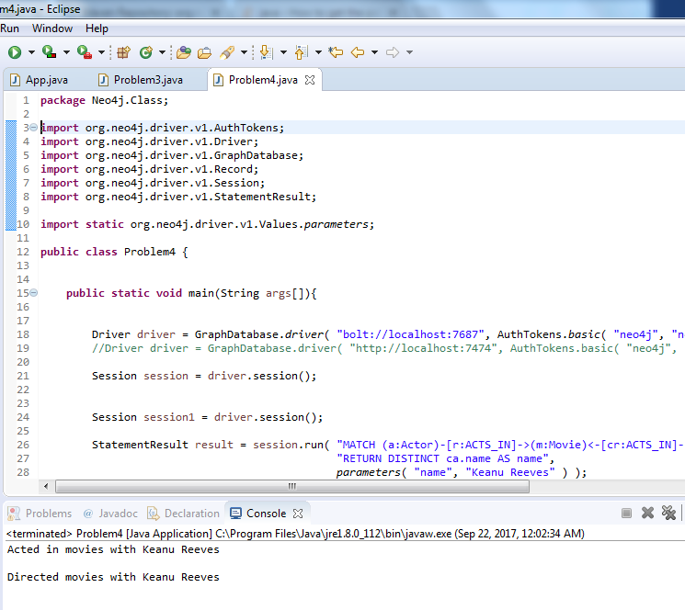

**Problem 5**. Find a way to export data from Neo4j into a set of CSV files. Delete your database and demonstrate that you can recreate the database by loading those CSV files. Please use any programming language of your convenience: Java, Python, R, C# or Scala.

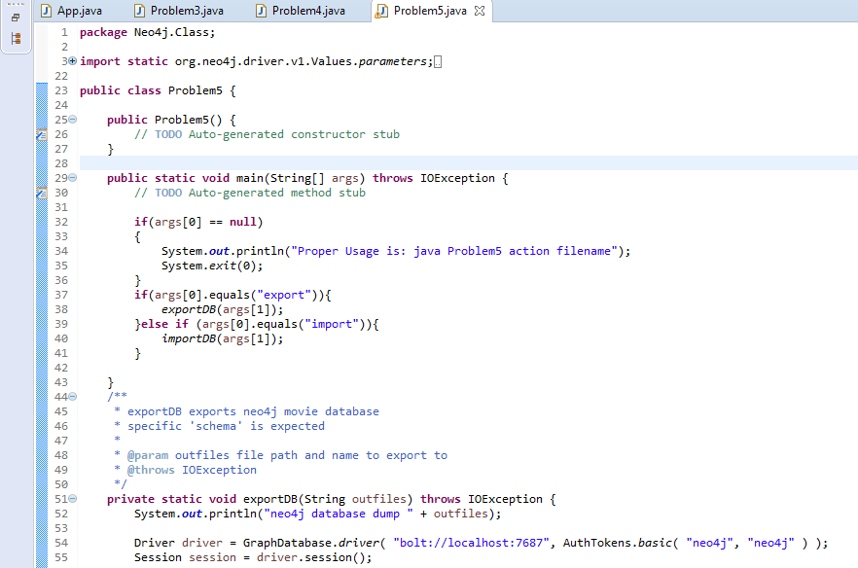

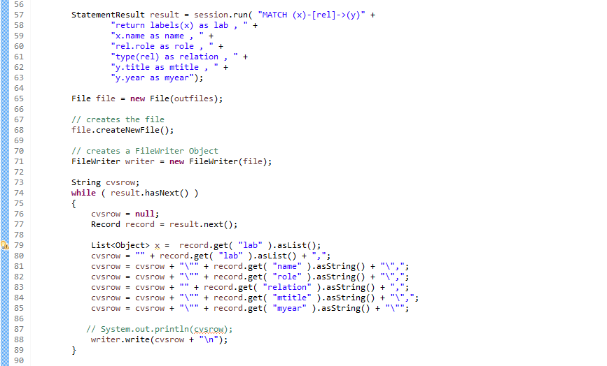

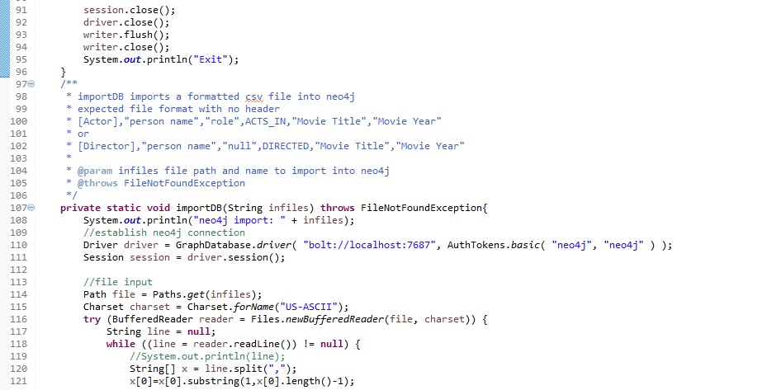

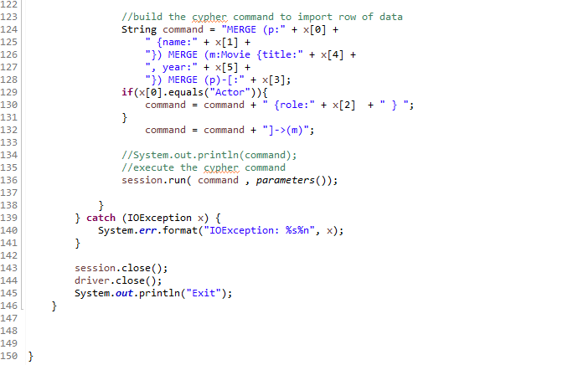

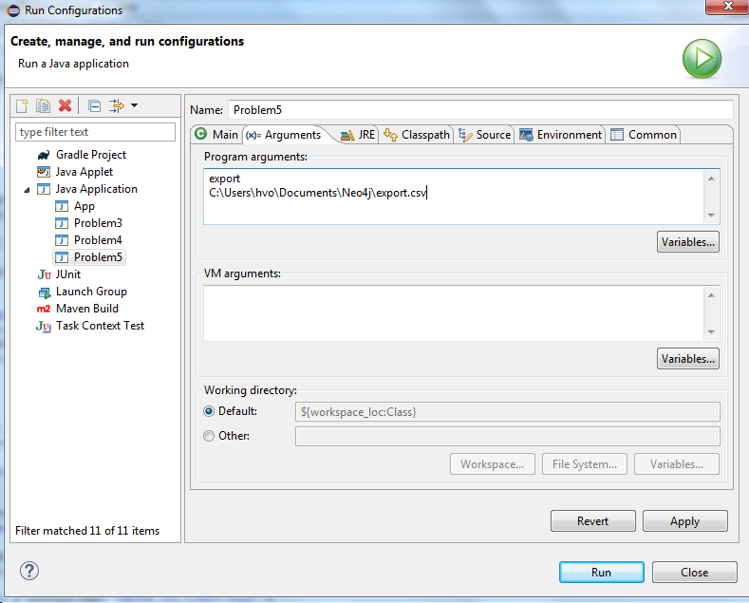

**Problem 6.** Find a way to use Arrow Tool (<http://www.apcjones.com>) to paint a relationship between a dog and his owner who live in New York and walk through the Central Park on Sunday afternoon. Add Labels and necessary properties to all nodes and relationships. Export your graph in Cypher format and then adjust (if necessary) generated Cypher so that you can create that graph in Neo4J database. Verify that your graph is indeed created using Cypher Browser.

